Si_boiling.csv

min(d(ln(I₀))/ln(I₀)): [0.003364847761195105, -19.287425793407518, 0.064899251500164012, 21.569043159866997, 0.11788402712191773, 8, 33]

min(ln(I₀)): -20.4721783835

max(ln(I₀)): -18.7518036645

ln(I₀) = -19.2874257934 ± 0.862632138457

Si_room.csv

min(d(ln(I₀))/ln(I₀)): [0.0054671191239273904, -26.296525341247566, 0.14376623658597582, 27.519527007158466, 0.21100192110592575, 18, 32]

min(ln(I₀)): -31.3918705993

max(ln(I₀)): -25.8712394362

ln(I₀) = -26.2965253412 ± 2.76405695322

Si_ice.csv

min(d(ln(I₀))/ln(I₀)): [0.00594827734086667, -32.148846049532686, 0.19123025249144623, 34.547591234200816, 0.2789938135991103, 5, 15]

min(ln(I₀)): -32.4131418151

max(ln(I₀)): -26.749762371

ln(I₀) = -32.1488460495 ± 2.83813947708

Si_dryice.csv

min(d(ln(I₀))/ln(I₀)): [0.010674105497978703, -45.421251628361929, 0.48483123173137216, 44.373289914038594, 0.57218302565996448, 7, 23]

min(ln(I₀)): -47.7186166411

max(ln(I₀)): -41.3372582517

ln(I₀) = -45.4212516284 ± 3.22730461019

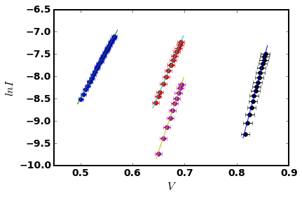

Using eq(2) to fit:

EgResult (array([ 13.26249024, -12154.71443381]), array([[ 5.33583077e+00, -1.76269905e+03],

[ -1.76269905e+03, 6.03291675e+05]]))

slope = -12154.7144338 ± 776.71853023

Eg = 1.04737174276 ± 0.0669298357499

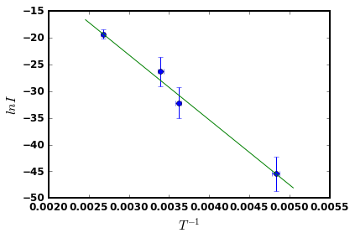

Using eq(3) to fit:

Eg Result with eq(3) (array([ 23.2916521 , -12584.06056741]), array([[ 5.30608241e+00, -1.75287167e+03],

[ -1.75287167e+03, 5.99928219e+05]]))

slope = -12584.0605674 ± 774.550333482

Eg = 1.08436849909 ± 0.0667430022362

